pm2 start server.js

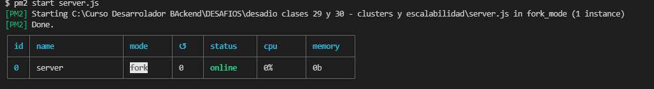

pm2 start server1.js

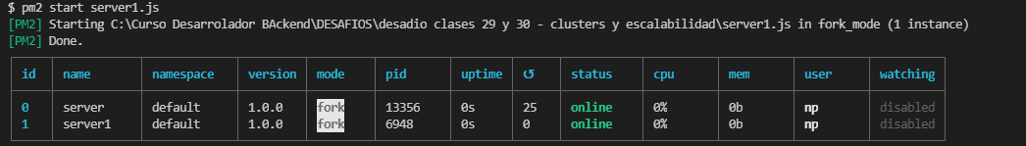

pm2 start server2.js

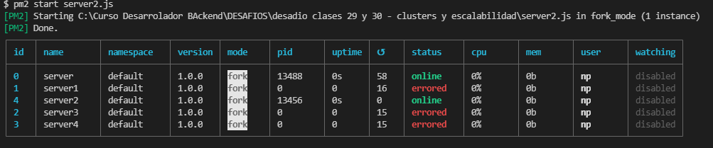

pm2 start server3.js

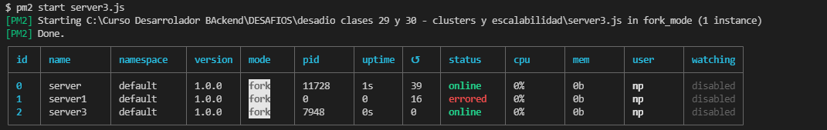

pm2 start server4.js

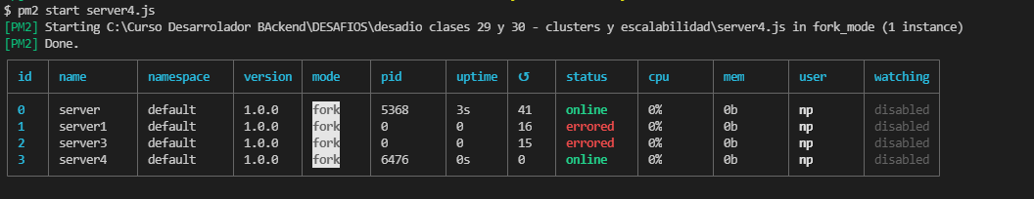

pm2 start serverIndividual.js

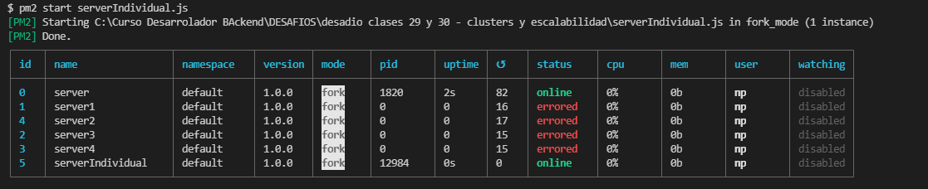

pm2 start serverCluster.js --watch -i max -- 8081

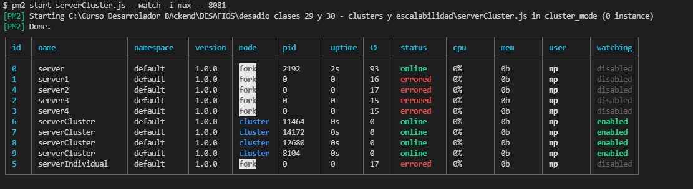

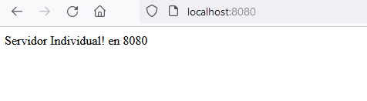

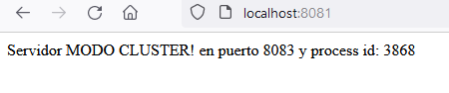

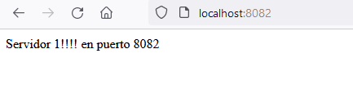

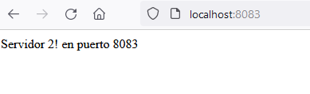

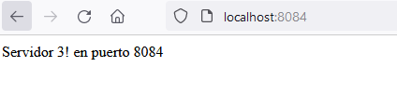

$ pm2 delete all

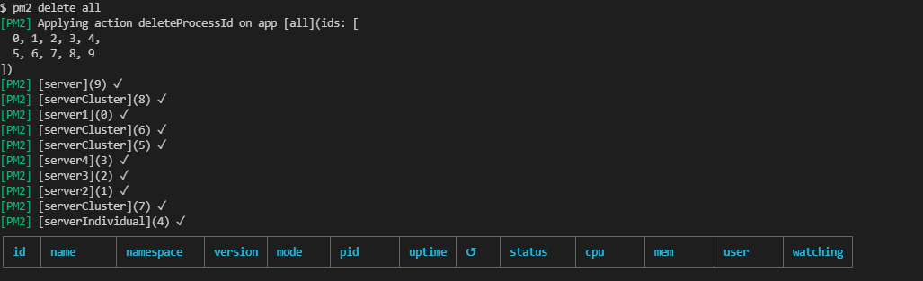

---------------------------------------------------------------------------------------------------------

npm run forever -- --port=8080 --CLUSTER=on //corre el server con forever mas parametros